Attendance using Face Recognition System

Pratham Lalwani AU2040260  
B.tech CSE  
Ahmedabad UniversityAhmedabad, India  
[pratham.l@ahduni.edu.in](mailto:pratham.l@ahduni.edu.in)

Daksh Suthar AU2040167  
B.tech CSE  
Ahmedabad UniversityAhmedabad, India  
[daksh.s@ahduni.edu.in](mailto:daksh.s@ahduni.edu.in)

***Abstract*—The attendance system is used to know whether the student is attending the lecture or not. There are various methods of taking attendance like paper-based, using biometrics, card based, face recognition based attendance etc. Among all of them, face recognition based d attendance system is more secure and time-saving. Face Recognition is used to recognize the students’ face by using face biometrics and take attendance. There are various algorithms of face recognition like LBPH, eigenfaces, fisherfaces, SURF etc. Among them, Local Binary Pattern Histogram (LBPH) algorithm is better. We are using Haar Cascade for face detection because of their robustness and LBPH algorithm for face recognition. It is robust against monotonic grayscale transformations [2].**

***Keywords—face detection, face recognition, attendance system, Haar cascade algorithm, LBPH algorithm***

# Introduction

In recent years, technology has advanced rapidly and has provided various solutions to different problems. One of these problems is attendance management which is very important in many organizations, schools and universities. The traditional methods of taking attendance such as using paper and pen, are time-consuming and its complexity increases with increase of overall strength. To overcome these challenges, face recognition technology has been an efficient solution. To implement this technology, we are using algorithms, such as Haar Cascade and Local Binary Pattern Histograms (LBPH) to accurately identify and recognize faces. The attendance system using face recognition using Haar Cascade and LBPH algorithms provides a more efficient and reliable method for attendance management. This system is automated which eliminates the need for paper based attendance and reduces the rate of errors. Moreover, it can be used in taking attendance in real-time which is essential in organizations. Therefore, this attendance system using face recognition using Haar Cascade and LBPH algorithms is an innovative solution that can change attendance management in various industries.

# Literature survey

Face recognition technology attendance systems have become increasingly popular in recent years due to their accuracy and convenience. These systems work by analysing the unique facial features of individuals and matching them with a database of known faces. One of the commonly used algorithms in this field is the Local Binary Pattern Histogram (LBPH), which extracts the local features of an image and constructs a histogram to represent them. Another popular algorithm is the Haar Cascade, which uses a cascade of classifiers to detect faces based on their features, such as edges and lines.

These attendance systems eliminate the need for physical contact or the need to carry any identification card, making them more hygienic and less prone to fraud. They also provide real-time updates and easy tracking of attendance records. However, these systems also have some limitations, such as proper lighting and camera angles and the potential for false positives or negatives. Overall, face recognition attendance systems have shown great potential in improving attendance management in various sectors such as education, healthcare, and corporate environments.

# Implementation

So, basically there are two algorithms used in this project of attendance system using face recognition: Haar cascade algorithm and LBPH algorithm.

The project can be categorised into four parts:

1. Capturing images
2. Training images
3. Recognising face
4. Marking present in CSV file

*1. Capturing images:*

The proposed system is designed to capture images, detect faces using a haar cascade, train the images, recognise faces, and mark attendance. The system captures 150 images of the students and stores them in a folder. The system then uses a haar cascade to detect faces in the images. Once the faces are detected, the system takes the user id and name of the student and also stores this data in a CSV file.

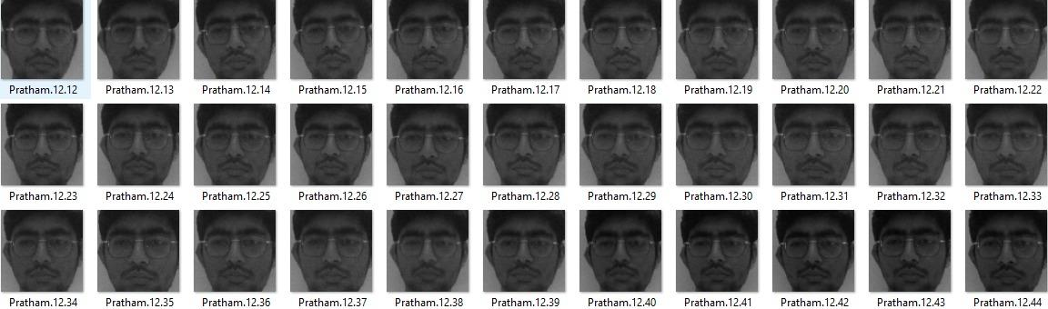

*2. Training images:*

The system then trains the captured images using the captured user id and name and captures the features of face (weights and bias) in a .yml file.

*3. Recognising face:*

The trained images are then compared with the webcam feed. The system uses a threshold of 60 for confidence level. Once the threshold is crossed, attendance is added to a CSV file.

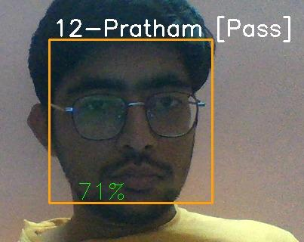

*4. Marking present in CSV file:*

The CSV file stores the details of the students, including their user id, name, and attendance status once the confidence level crosses the threshold. The attendance status is marked with the student's name, date, and time based on the recognition of their face.



# Discussion

*1. Haar Cascade Algorithm*

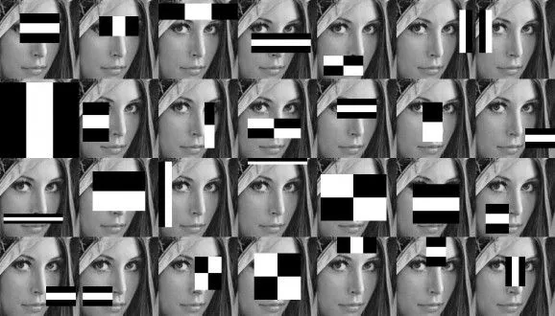

Source: [Haar Cascades, Explained. A brief introduction into Haar... | by Aditya Mittal | Analytics Vidhya | Medium](https://medium.com/analytics-vidhya/haar-cascades-explained-38210e57970d)

Haar cascade Algorithm is used to detect the face of the person. Haar cascade uses the cascade function and cascading window. It tries to calculate features for every window and classify positive and negative. If the window could be a part of an object, then positive, else, negative [3]. The algorithm is divided into four stages:

* Calculating Haar features
* Creating integral images
* Using adaboost
* Implementing Cascading classifiers

*2. Local Binary Pattern Histograms(LBPH)*

This is a face recognition algorithm which is used to recognize the face of the person from both front face and side face. This algorithm is based on LBP approach. The main idea behind LBP is to describe the neighborhood of image elements using binary codes. This method is usually used to study their local properties and identify the characteristics of individual parts of the image [5].

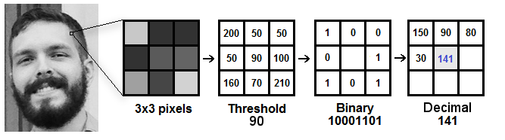

Source: [Understanding Face Recognition using LBPH algorithm - Analytics Vidhya](https://www.analyticsvidhya.com/blog/2021/07/understanding-face-recognition-using-lbph-algorithm/)

The LBPH features are typically represented as a histogram, where each bin represents a particular pattern and its frequency in the image. This histogram is then used as input to the classifier.

This algorithm is robust when it comes to lightning. The value of pixels will increase when a flashlight is put on the image. Higher the values the brighter the image and when values are lower darker the image will be[6]. For this reason, this algorithm has good results in light and dark images because when the image becomes lighter or darker, all the pixels in the neighbourhood here will be changed[6].

# Results

The face recognition system using the Haar cascade and Local Binary Patterns Histograms (LBPH) algorithm was successfully implemented and tested on a dataset of 150 images of each person.

The system can track individuals' attendance in a classroom setting using a webcam. The system can detect and recognise students' faces and record their attendance automatically.

Furthermore, the Euclidean distance is calculated and providing the output by getting the closest distance between histograms of trained images and testing images.

Overall, the results demonstrate that the face recognition system using the Haar cascade and LBPH algorithm is an effective and reliable tool for tracking attendance in a classroom setting. The system can be easily integrated with existing attendance management systems and help automate the attendance tracking process, saving time and reducing errors.

##### References

[1] Dr.B.KameswaraRao,B.Anusha,G.Shiridi,B.Radhika,A.Vineeth, "ATTENDANCE SYSTEM BASED ON FACE RECOGNITION USING LBPH ", International Journal of Creative Research Thoughts (IJCRT), ISSN:2320-2882, Volume.8, Issue 5, pp.1267-1277, May 2020, Available at :<http://www.ijcrt.org/papers/IJCRT2005173.pdf>

[2] B. Tej Chinimilli, A. T., A. Kotturi, V. Reddy Kaipu and J. Varma Mandapati, "Face Recognition based Attendance System using Haar Cascade and Local Binary Pattern Histogram Algorithm," 2020 4th International Conference on Trends in Electronics and Informatics (ICOEI)(48184), Tirunelveli, India, 2020, pp. 701-704, doi: 10.1109/ICOEI48184.2020.9143046.

[3] Jaiswal, A. (2022, October 19). Face Detection using Haar-Cascade using Python Uncategorized. Analytics Vidhya. [https://www.analyticsvidhya.com/blog/2022/10/face-detection-using- haar-cascade-using- python/#:~:text=Haar%20Cascade%20is%20a%20feature](https://www.analyticsvidhya.com/blog/2022/10/face-detection-using-)

[4] Mittal, A. (2020, December 21). Haar Cascades, Explained. Medium. [https://medium.com/analytics-vidhya/haar-cascades-explained- 38210e57970d](https://medium.com/analytics-vidhya/haar-cascades-explained-)

[5] Harmouch, M. (2021, May 28). Local Binary Pattern Algorithm: The Math Behind It️. The Startup. [https://medium.com/swlh/local-binary- pattern-algorithm-the-math-behind-it-%EF%B8%8F-edf7b0e1c8b3](https://medium.com/swlh/local-binary-)

[6] Understanding Face Recognition using LBPH algorithm. (2021, July 12).AnalyticsVidhya. [https://www.analyticsvidhya.com/blog/2021/07/understanding-face- recognition-using-lbph-algorithm/](https://www.analyticsvidhya.com/blog/2021/07/understanding-face-)